Exercise 6 Answers and Analysis: Monitoring progress

Project background and context:
All progress charts are extracted from the same project at various points of time in the project life cycle. The team 3 graphs show the project in its entirety. Release 1 and 2 were planned together at the start of the project and the graphs clearly show that the project ran very smoothly for the first 2 releases. As you can see from the graph, in Release 3 an extremely large amount of scope (ie stories) was added. The reason for this is Release 3 was planned and estimated half way through release 2, and although the estimate LOE and staffing plan balanced out, what it did not take into consideration was team productivity. The team productivity could have easily been extracted from the progress charts, and then compared with the story points planned (by looking at the total of the ABP) for the release.

----------------------------------------------------------------------------------------------------------------------------
Team 1:
The project is being planned and executed on a release by release basis
Iteration length: 2 weeks
Current release: 2
Current iteration: 9
Staffing:
Iteration 5: 6
Iteration 6: 8
Iteration 7: 8
Iteration 8: 8
Iteration 9: 6

Velocity
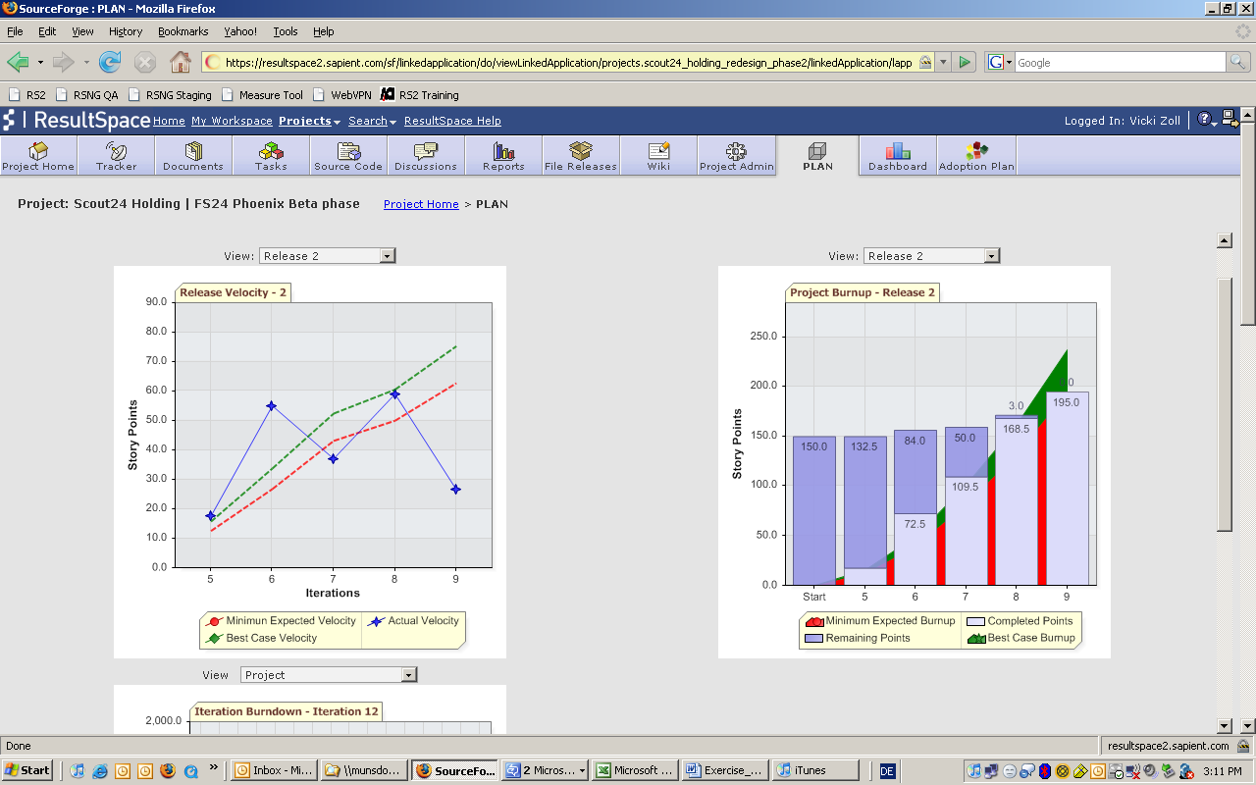

Burnup

Analysis:
For the duration of release 2 the project is tracking to plan, and is able to complete the planned scope on time. A couple of points to note:
- There was a slight increase in scope in iterations 6, 7, 8 and a larger increase in scope in iteration 9. Regardless of this, the team was able to close the stories on time.
- it is critical to not view each graph in isolation, as the combination provides overall insight eg if you only look at the Velocity chart, it looks like the team was not on track in iteration 7 and 9, however if you look at this in combination with the Burnup chart, it becomes clear that the team was able to achieve the overall goals as indicated by 0 story points remaining in iteration 9.

----------------------------------------------------------------------------------------------------------------------------

Team 2:
The project is being planned and executed on a release by release basis. Assume that the team size has been stable for the last 2 releases, and productivity on average has been 50 story points per iteration.
Iteration length: 3 weeks
Current release: 3
Current iteration: 12
Staffing:
Iteration 10: 7 people,
Iteration 11: 8 people,
Iteration 12: 9.5 people,
Iteration 13: 10 people,
Iteration 14: 8 people

Velocity
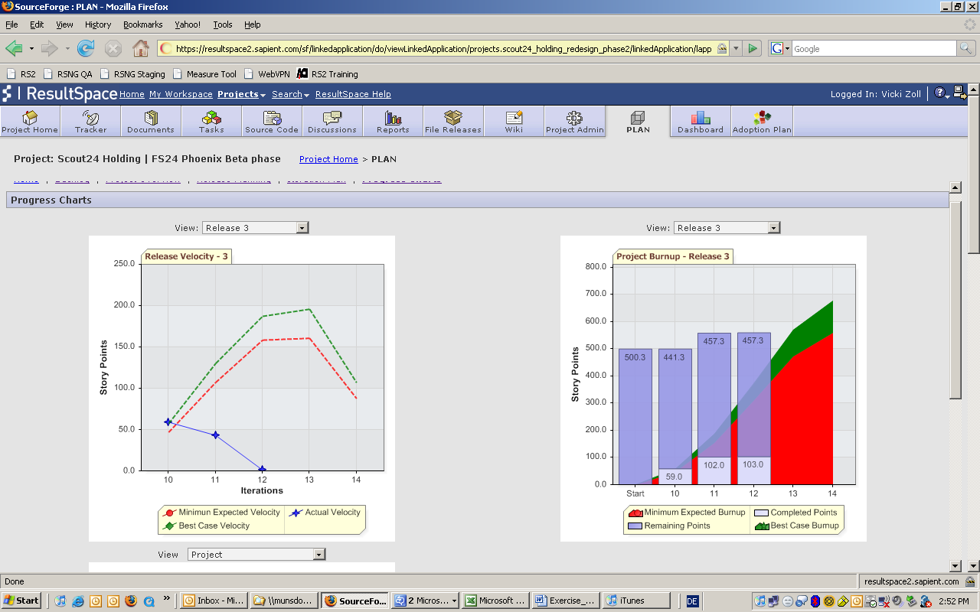

Burnup

Analysis:
Given the history of the team and the fact that productivity of the team has been constant for the first 2 releases, the graphs clearly indicate that there is a mismatch between what the team can achieve and what is in scope. Since the team is at the start of iteration 12, we can look at historical data, and assume that the team will continue to achieve approximately 50 story points per iteration. This is clearly less than what is needed.

Calculations for adding people or time:
Iteration | 10 | 11 | 12 | 13 | 14
Capacity | 7 | 8 | 9.5 | 10 | 8
Actuals (from the graphs):
Actual velocity | 59 | 43
Actual accumulated velocity | 59 | 102
Remaining velocity | 441.3 | 457.3 | 457.3
Predicted:
Velocity needed to achieve remaining stories in the given time frame (457/3 rounded) |  |  | 150 | 150 | 150
Predicted velocity |  |  | 50 | 50 | 50
Predicted accumulative velocity |  |  | 152 | 202 | 252
Predicted remaining velocity |  |  | 457-50 =407 | 407-50 = 357 | 357-50 =307

Option 1: Increase the team size
Given that the velocity needed to complete all remaining stories (459.3 story points) within the given timeframe is 150 stories per iteration, and given that the team has only achieved on average 50 story points with an average team size of 9, we can assume that we need to triple the team size.
Obviously this is not a realistic solution, as increasing the team size by this much will not increase productivity, and may in fact decrease productivity.

Option 2: Extend the project timeline
Given that the predicted velocity is 50 story points per iteration, at the end of iteration 14, the predicted remaining velocity is 307. If we were to keep the current team size to be on average 9 people, this indicates that we would need to extend the project by 6 iterations (307/50 = 6). More than likely this is not an acceptable solution for the client.

Option 3: Decrease scope
Speak with the client about significantly decreasing scope. This would require removing or postponing stories from this release worth approximately 300 story points.

Option 4: Decrease scope and push out timeline
The most realistic option is a combination of option 2 and 3. The team needs to look at how much scope (or stories) can be removed, and see what it left. Then use that to figure out how much the timeline needs to be extended by.

Team 3:
The project is a fixed time, fixed price engagement. We have committed to delivering 3 releases.
Iteration length: 3 weeks
Current release: 3
Current iteration: 12
Staffing:
Release 1: Iterations 1–5, 4-6 people
Release 2: Iterations 6–9, 6-8 people
Release 3: Iteration 10–14, 8-10 people

Velocity Chart
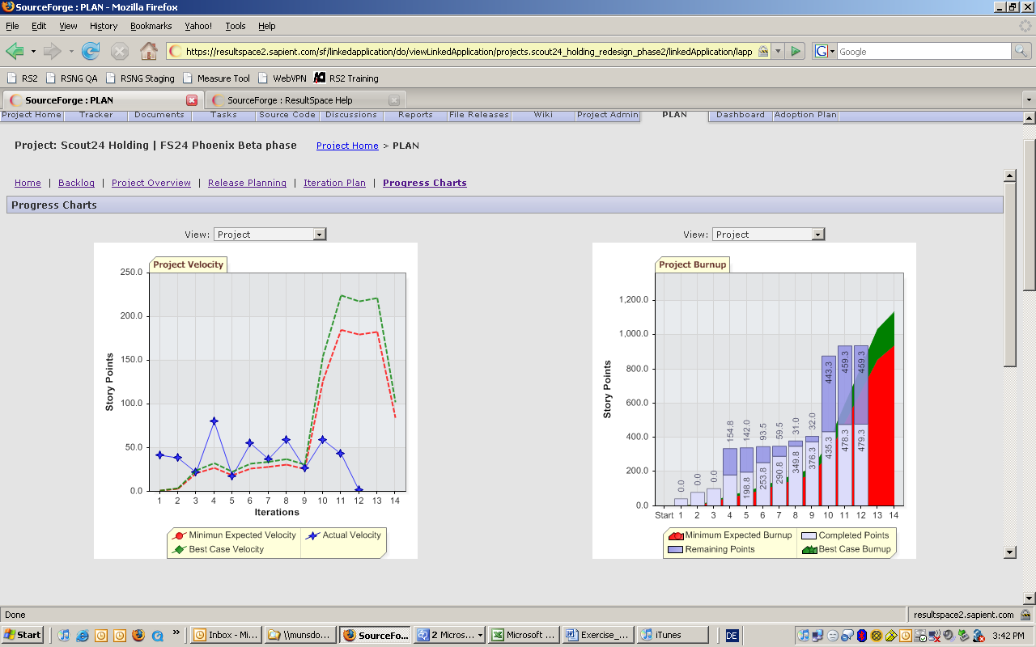

Burnup Chart

Analysis:
The analysis for these graphs is essentially the same as for team 2. However, the biggest difference is that these graphs show the full picture for the project to date as opposed to only release 2, hence we can make more definitive predictions as we have more historical data to back us up.

Calculations for adding people or time:
Release | 1 | 2 | 3
Iteration | 1-5 | 6-9 | 10 | 11 | 12 | 13 | 14
Capacity | 5 | 7 | 7 | 8 | 9.5 | 10 | 8
Actuals (from the graphs):
Actual velocity (av) | 50 | 50 | 59 | 43
Actual accumulated velocity
Remaining velocity | 142 | 32 | 443.3 | 459.3 | 459.3
Predicted:
Velocity needed to achieve remaining stories in the given time frame (457/3 rounded) |  |  |  |  | 150 | 150 | 150
Predicted velocity |  |  |  |  | 50 | 50 | 50
Predicted accumulative velocity |  |  |  |  | 152 | 202 | 252
Predicted remaining velocity |  |  |  |  | 457-50 =407 | 407-50 = 357 | 357-50 =307

Option 1: Increase the team size
Given that the velocity needed to complete all remaining stories (459.3 story points) within the given timeframe is 150 stories per iteration, and given that the team has only achieved on average 50 story points regardless of the team size (av team size is 6), we can assume that we need to triple the team size.
Obviously this is not a realistic solution, as increasing the team size by this much will not increase productivity, and may in fact decrease productivity.

Option 2: Extend the project timeline
Given that the predicted velocity is 50 story points per iteration, at the end of iteration 14, the predicted remaining velocity is 307. If we were to keep the current team size to be on average 9 people, this indicates that we would need to extend the project by 6 iterations. More than likely this is not an acceptable solution for the client.

Option 3: Decrease scope
Speak with the client about significantly decreasing scope. This would require removing or postponing stories from this release worth approximately 300 story points.

Option 4: Decrease scope and push out timeline
The most realistic option is a combination of option 2 and 3. The team needs to look at how much scope (or stories) can be removed, and see what it left. Then use that to figure out how much the timeline needs to be extended by.

